**COE 768: Mid-Term Test**

**2012**

* There are **Five** questions. Answer **ALL** of them. The points assigned to the questions are indicated at the beginning of the questions. The total points of this paper are 100.
* If doubt exists as to the interpretation of any question, the student is urged to submit with the answer paper, a clear statement of any assumption made.
* Time limit: 1 hour 50 minutes.

**Student Name:**

**Student ID:**

|  |  |
| --- | --- |
| **Question** | **Marks** |
| Question 1 (10%) |  |
| Question 2 (20%) |  |
| Question 3 (20%) |  |
| Question 4 (25%) |  |
| Question 5 (25%) |  |
| **Total**  **(100%)** |  |

**Problem 1 (10 points)**

Consider the connection between a server and a PC as illustrated in the following figure. The IP addresses and the Ethernet addresses are also shown in the figure. Sketch the sequences of IP packets and Ethernet frames that are generated by the data transfer from the PC to the server. Include the IP addresses, MAC addresses, Ethernet type fields and IP protocol fields in the sketch.

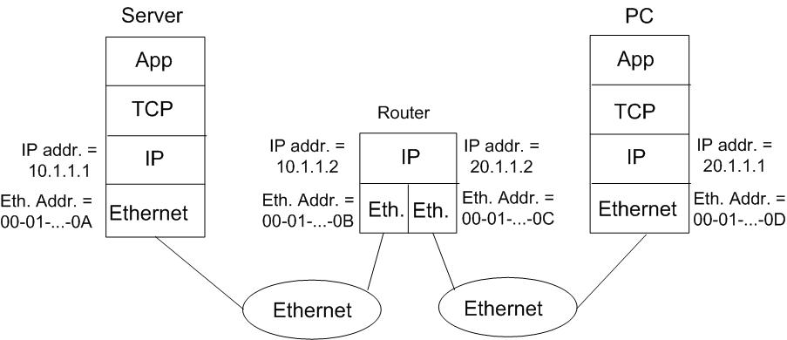

**Problem 2 (20 points)**

A data Link entity is sending one byte data 10011010 to its peer entity. A checksum of 4 bits is generated using 1’s complement method and is appended to the byte. The transmission uses 4B/5B coding. Sketch the transmitted waveform that represents the byte and the checksum, assuming the signal level is high before the transmission of the byte. The following is the 4B/5B coding table.

**Problem 3 (20 points)**

Consider the following point-to-multipoint configuration:

Primary

Station

**B**

**A**

Secondary Stations

The time diagram below illustrates the data exchanges between the primary station and the secondary stations using HDLC normal response mode with Go-Back-N protocol.

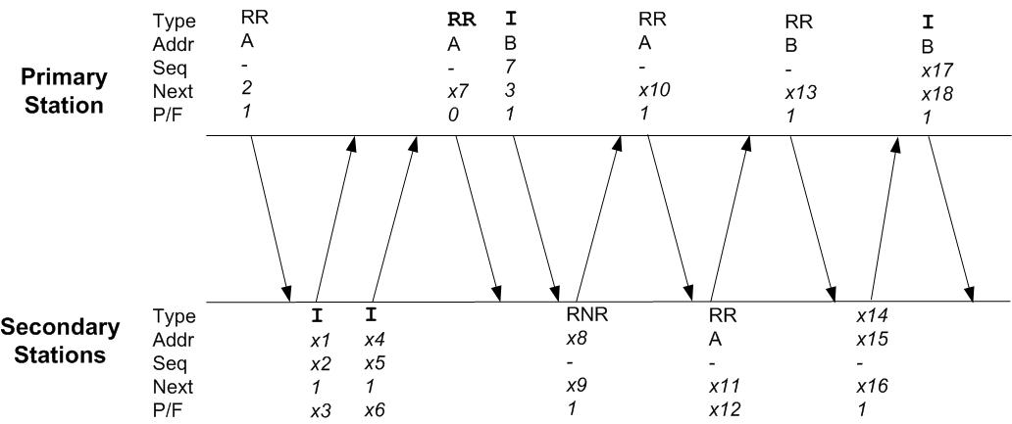

Each frame carries a type field (Type), address field (Addr), next field (Next), the P/F bit, and possibly the sequence number field (Seq). The diagram shows the values in some of the fields. Assume all the windows of the stations are synchronized initially and all the frames are received correctly. Determine all the unknown values in the diagram, from *x1* to *x18.*

**Problem 4 (20 points)**

Consider the following 100-Mbps Ethernet LAN with a star topology:

**hub**

100 m

100 m

50 m

**StationB**

**StationC**

**. . .**

**StationA**

The cables that connected Stations A, B and C to the hub are 100m, 50m and 100m, respectively. The signal propagation speed is 2×108 m/sec. The hub introduces a 2-µsec delay. Station A starts to transmit a frame at *t=*0*.* BothStations B and C also prepare to transmit frames at *t=*2.85µsec.

1. **(15 points)** Determine the order of successful transmissions of these three stations. More specifically, determine which station will be the first to transmit successfully, and which one will be the second and which one the last. Suppose the sequence of randomvalues generated by the random number generators of stations A B and C used for binary exponential backoff scheduling are given as:
   * Station A: 0.54, 0.41, 0.39, 0.21
   * Station B: 0.89, 0.72, 0.58, 0.89
   * Station C: 0.72, 0.32, 0.60, 0.77

**(Note:** You must provide detailed analysis to support your answers)

1. **(10 points)** Based on your answer in part (a), estimate the time it takes for the successful transmission of all three frames, measured from *t*=0 to the time the last station successfully completes the transmission of its frame.Let the size of these frames be 1000 bytes each.

**Problem 5 (25 points)**

In lab 5, the file transfer application provides the file downloading from the server to the client using UDP. Modify both the server and client programs so that the application can also support file uploading from the client to the server. **You** **only need to show the portions of the program that is modified**. Your implementation must use the protocol as described in the following time diagram:

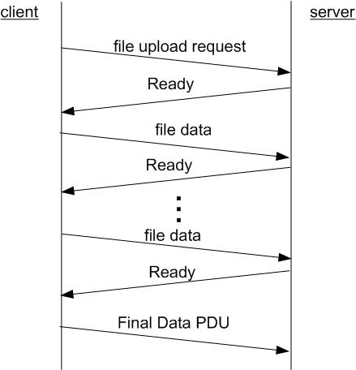

Essentially, the protocol requires the server to send back a Ready PDU every time it receives a PDU from the client (except the “Transfer completed” PDU). Correspondingly, the client will send a new data PDU only when it receives a Ready PDU. To simplify the program, assume that all the PDUs are received correctly.

(**Hint:** You can freely introduce addition PDU types in your program.)